Department | AIDS
Course Code / Course Name | DSA0602/ Data Handling and Visualization
Experiment | Data Visualization using R
Name | Ayesha Siddiqa S
Register Number | 192324305
Date | 15/10/2026
Day | Thursday
Set 24: Product Inventory Management

1. Bar chart of product quantities
Aim: To visualize the quantity available for each product.
Algorithm:
- Create the product inventory dataset.
- Plot product names on the X-axis and quantities on the Y-axis.
- Add bars, a title and axis labels.
- Save the dataset.
Code:
library(ggplot2)
inventory <- data.frame(
Product_ID = 1:5,
Product_Name = paste("Product", LETTERS[1:5]),
Quantity = c(250, 175, 300, 200, 220)
)

write.csv(inventory, "product_inventory.csv", row.names = FALSE)

ggplot(inventory, aes(x = Product_Name, y = Quantity, fill = Product_Name)) +
geom_col() +
labs(title = "Product Inventory Quantities",
x = "Product", y = "Quantity Available") +
theme_minimal()
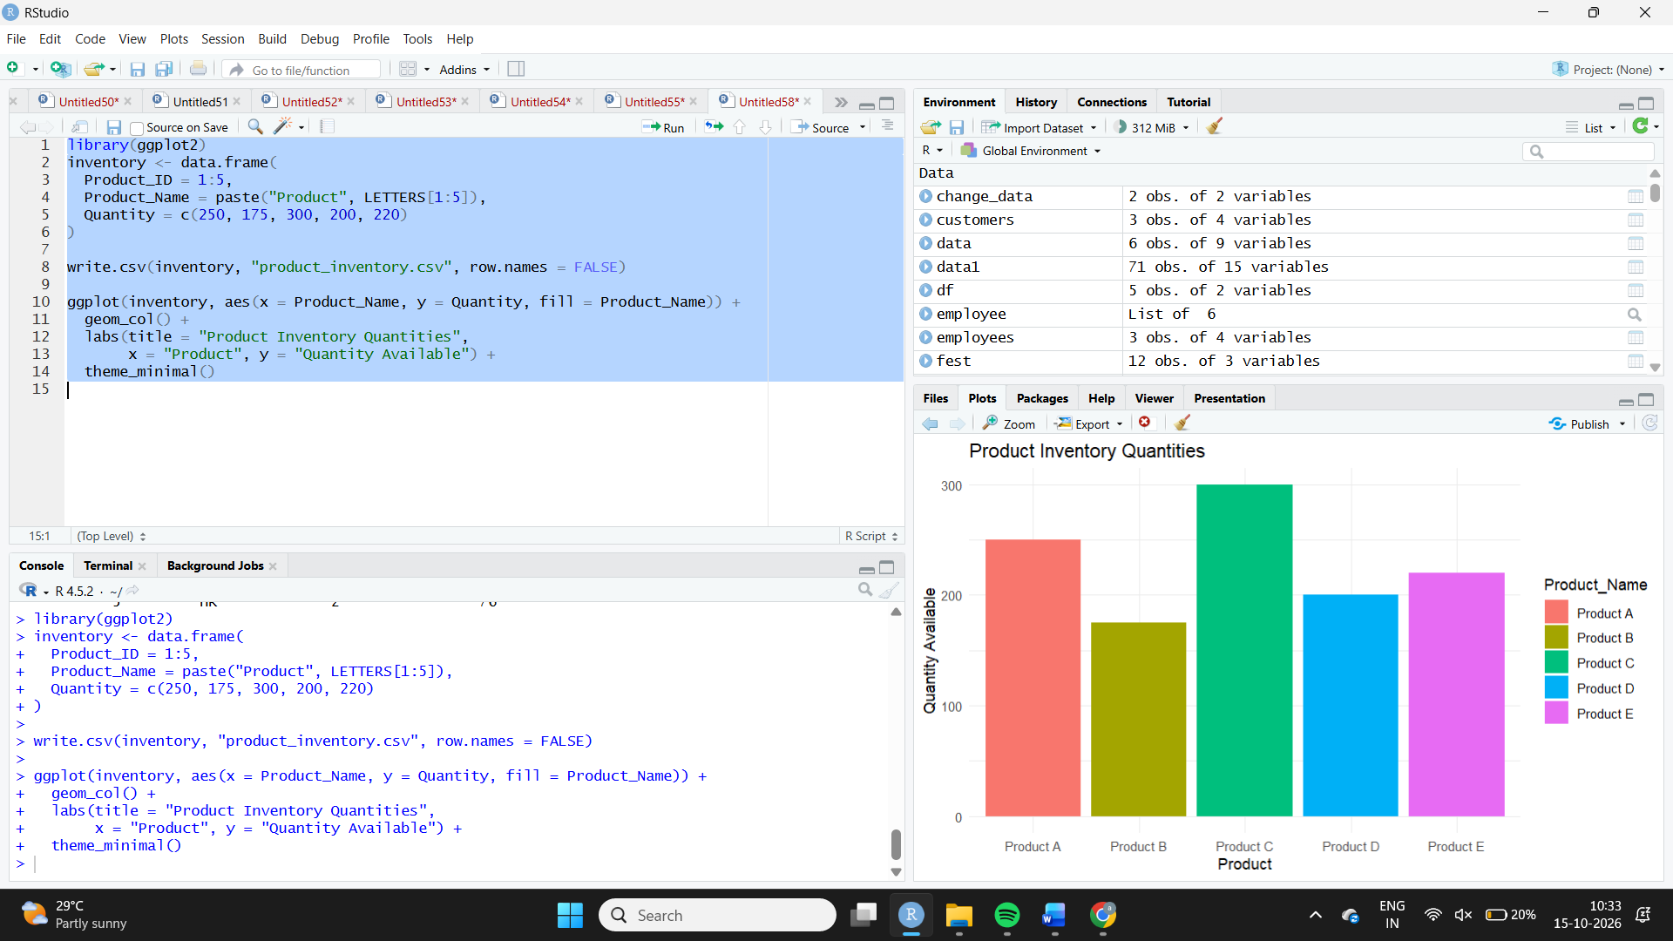
Observation: Product C has the highest inventory at 300 units, while Product B has the lowest at 175 units. The difference is 125 units.
2. Stacked bar chart by product category
Aim: To visualize product quantities across different product categories using a stacked bar chart.
Algorithm:
- Create a dataset containing product names, categories and quantities.
- Map product names to the X-axis and quantities to the Y-axis.
- Use category as the fill variable.
- Add a title and axis labels.
Code:
library(ggplot2)
category_data <- data.frame(
Product = c("Product A", "Product B", "Product C",
"Product D", "Product E"),
Category = c("Electronics", "Furniture", "Electronics",
"Furniture", "Accessories"),
Quantity = c(250, 175, 300, 200, 220)
)

write.csv(category_data, "inventory_by_category.csv", row.names = FALSE)

ggplot(category_data, aes(x = Product, y = Quantity, fill = Category)) +
geom_col() +
labs(title = "Product Quantity by Category",
x = "Product", y = "Quantity Available", fill = "Category") +
theme_minimal()
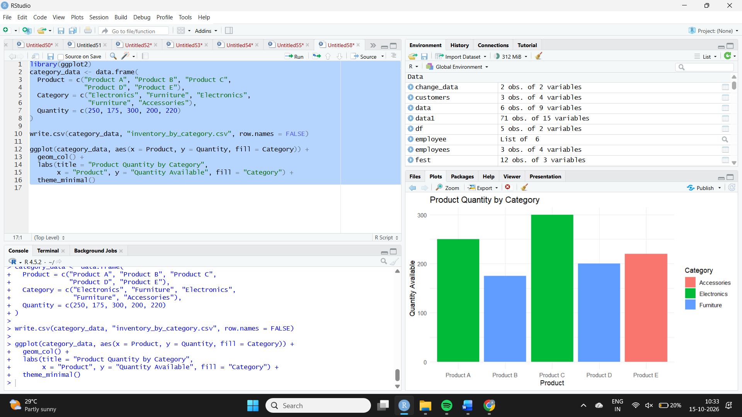
Observation: Product C has the largest quantity at 300 units. The stacked colors indicate each product's category. The category assignments in this example are illustrative because the original dataset does not specify product categories.
3. Tableau inventory dashboard
Aim: To combine a product quantity bar chart and a stacked bar chart for interactive inventory analysis.
Algorithm:
- Import the inventory dataset into Tableau.
- Create a bar chart of product quantity.
- Create a stacked bar chart using product and category.
- Add both charts to a dashboard.
- Add filters and labels for interactive exploration.
Procedure:
- Connect Tableau to product_inventory.csv.
- Drag Product Name to Columns and Quantity to Rows.
- Create a second worksheet using Product and Category, with Quantity on Rows and Category on Color.
- Enable stacked marks and add both sheets to a new dashboard.
- Add a category filter if the category data is available.
Observation: The dashboard allows users to compare stock levels across products and view quantities by category. Product C holds 300 units, the largest quantity in the supplied data. Accurate category comparisons require verified category information.
4. Scatter plot of product price and quantity
Aim: To investigate the relationship between product price and quantity available.
Algorithm:
- Create a dataset with product names, prices and quantities.
- Plot price on the X-axis and quantity on the Y-axis.
- Add points and a trend line.
- Interpret the relationship.
Code:
library(ggplot2)
price_data <- data.frame(
Product = paste("Product", LETTERS[1:5]),
Price = c(500, 300, 800, 450, 250),
Quantity = c(250, 175, 300, 200, 220)
)

write.csv(price_data, "product_price_quantity.csv", row.names = FALSE)

ggplot(price_data, aes(x = Price, y = Quantity, label = Product)) +
geom_point(size = 3, color = "blue") +
geom_text(nudge_y = 7, check_overlap = TRUE) +
geom_smooth(method = "lm", se = FALSE, color = "red") +
labs(title = "Product Price vs Quantity Available",
x = "Price ($)", y = "Quantity Available") +
theme_minimal()
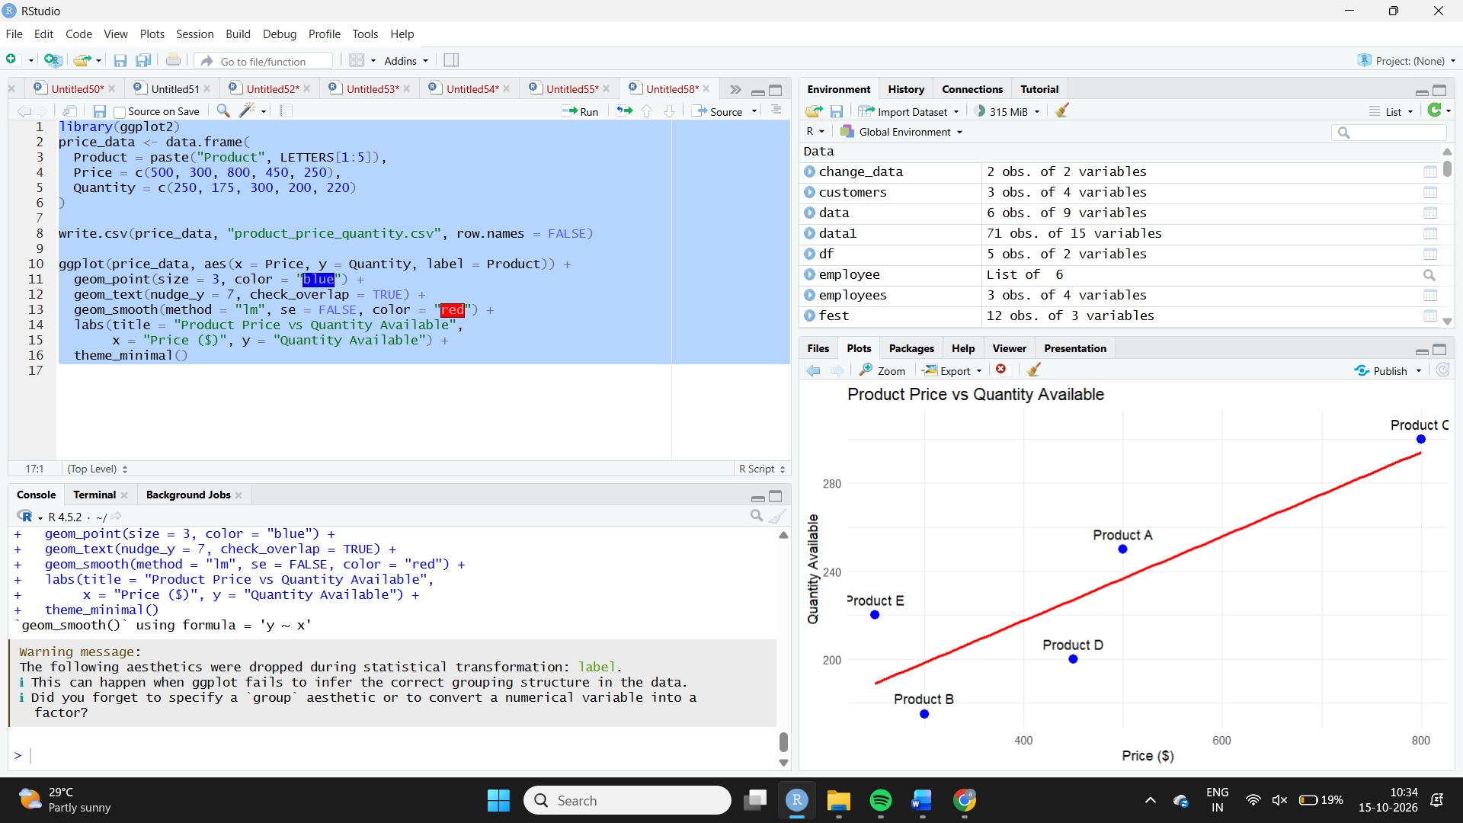

Observation: The illustrative data is used to demonstrate how price and inventory quantity can be compared. Product prices were not provided in the question, so no reliable conclusion about the actual relationship between price and quantity can be made from the supplied inventory data alone.

